STUPHORN LAB, TDT/NEUROPIXELS RIG: 3CH SYRINGE PUMP PIN MAPPING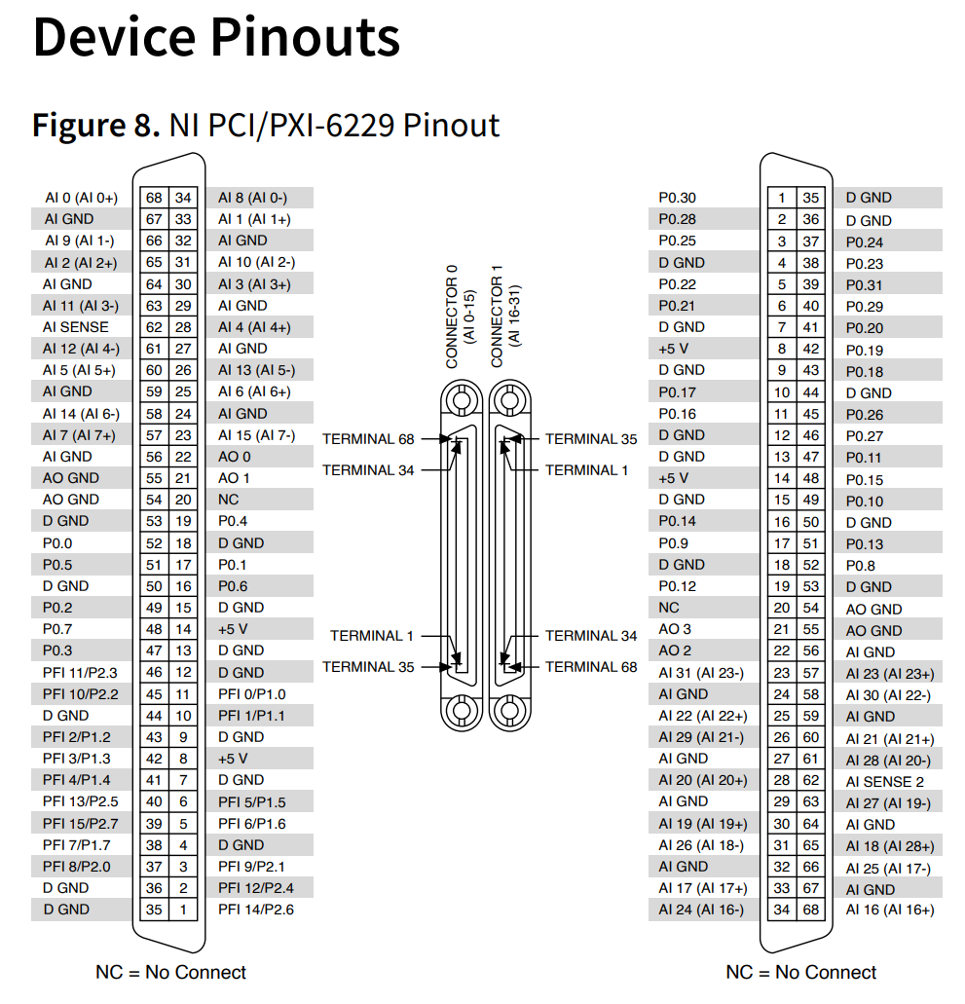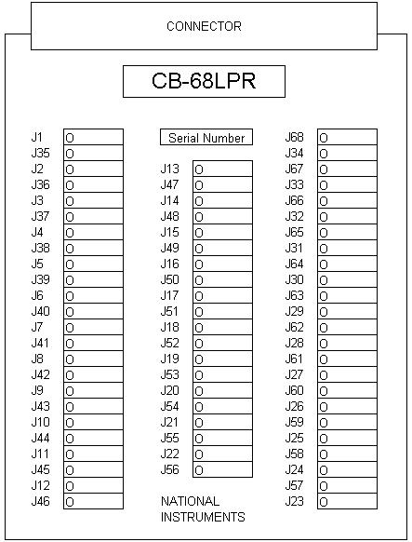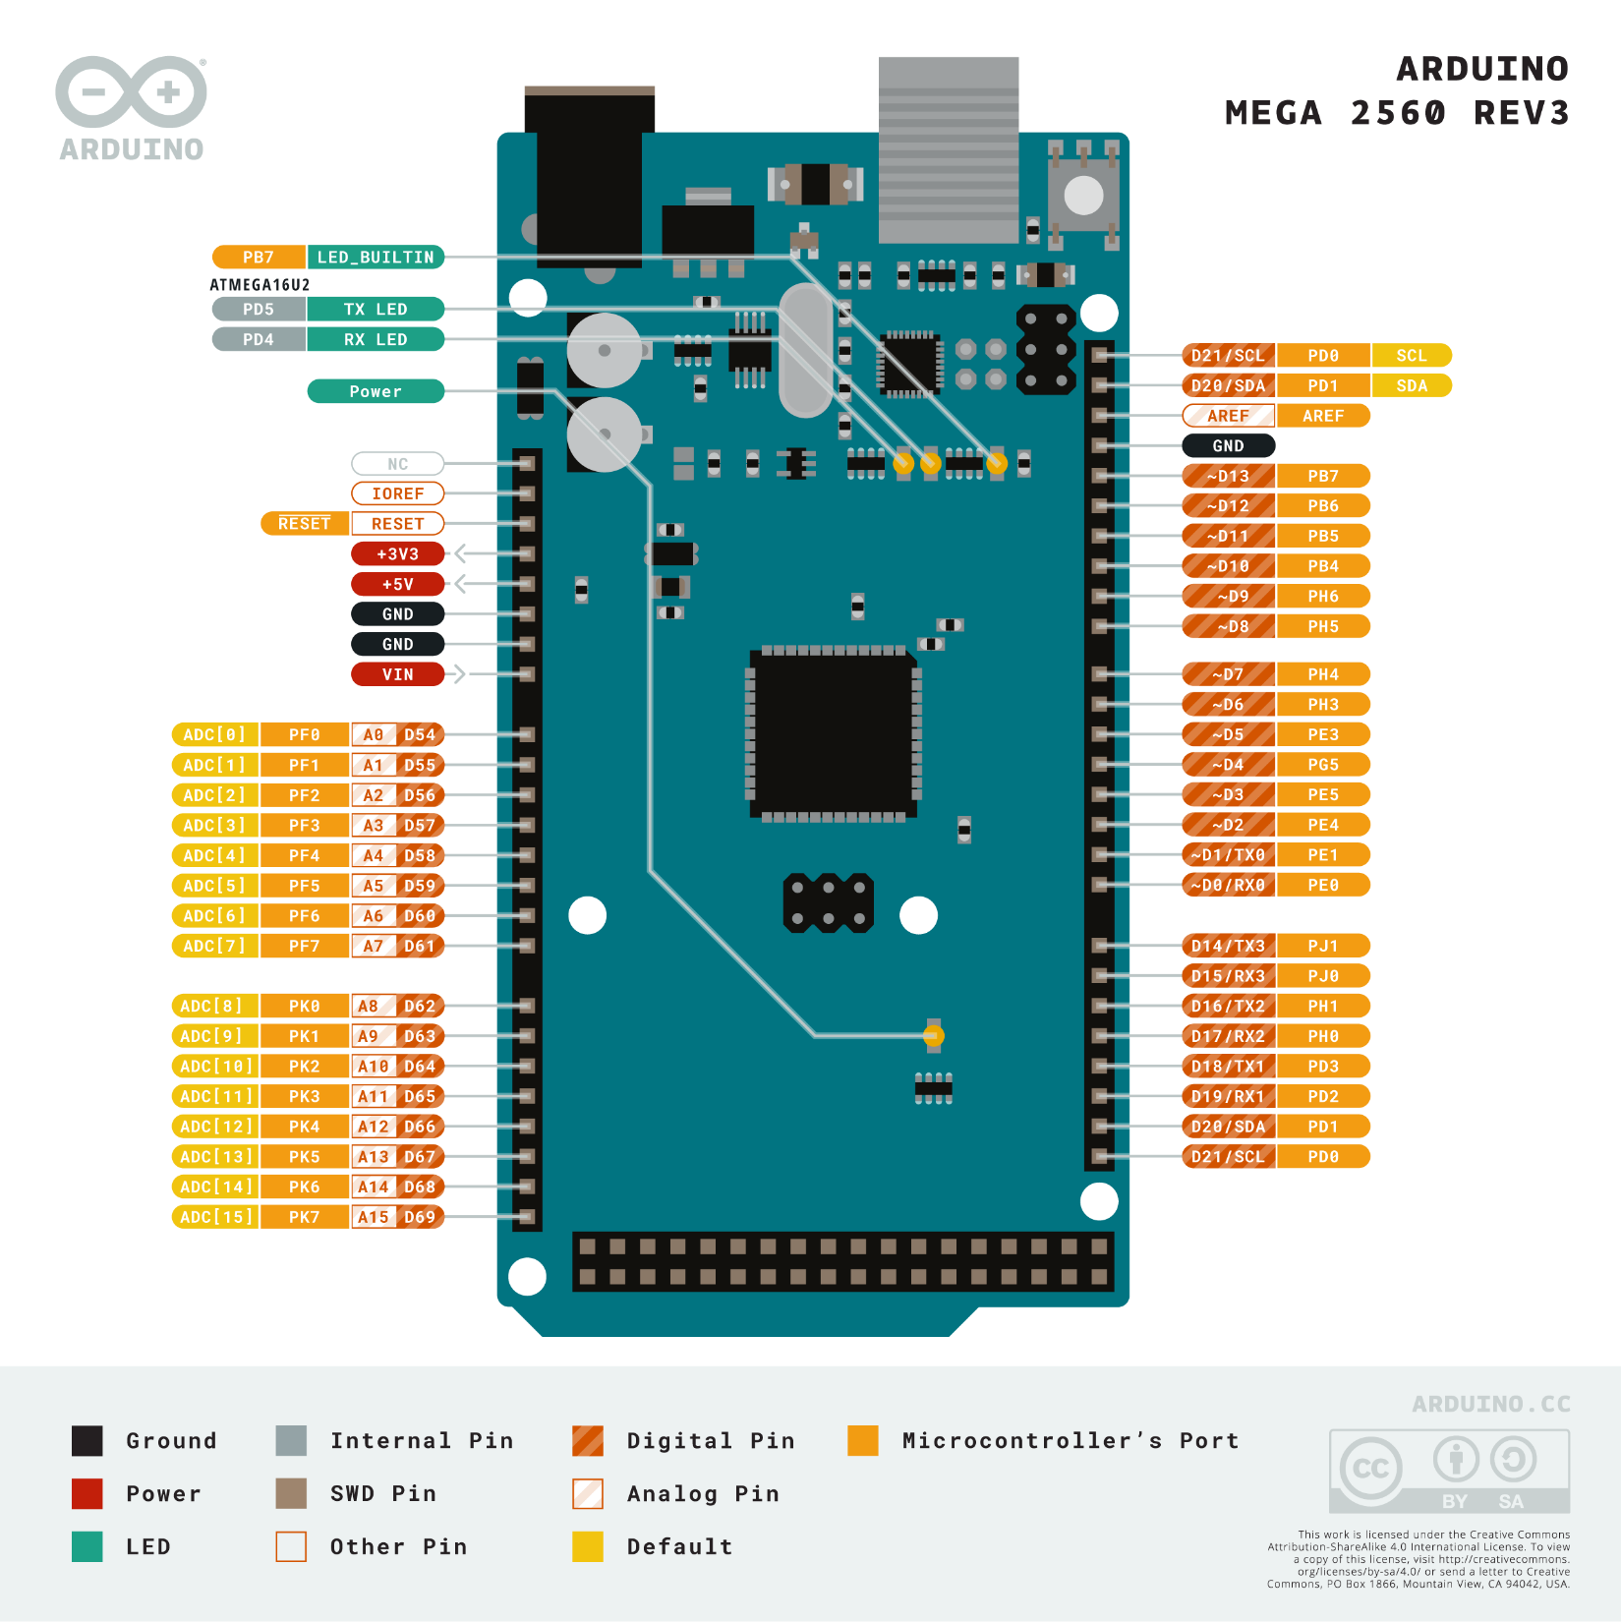
P0.3 <- D5

P0.7 <- D9

P0.2 <- D4

P0.6 <- D8

P0.1 <- D3

P0.5 <- D7

P0.0 <- D2

P0.4 <- D6

MEGA pins PCI-6229 pins
D9 P0.7
D8 P0.6
D7 P0.5
D6 P0.4
D5 P0.3
D4 P0.2
D3 P0.1
D2 P0.0

============================================================================

3-Channel Syringe Pump Controller for Arduino Mega
============================================================================
- Controls 3 stepper motors with auto-reversal at 0-40mm boundaries.
- Sends JSON messages to Raspberry Pi monitor via USB serial.

Monitors 8-bit GPIO input from external device (TDT/Plexon system):
- Bits 0-3: Magnitude (0-15, representing 1-16 units)
- Bit 4: Unused (reserved)
- Bits 5-6: Pump selection (10=Pump1, 01=Pump2, 11=Pump3)
- Bit 7: Trigger (rising edge triggers delivery)

GPIO Pin Mapping (reading left to right, Pin 2 to Pin 9):
Position: 0 1 2 3 4 5 6 7
Pin: 2 3 4 5 6 7 8 9
└──────┬──────┘ └─┬─┘ └─ Trigger
Amount Pump

Example encodings:
Pump 1, Amount 1: 00000101 (binary) = 0x05 (hex)
Pump 1, Amount 2: 10000101 (binary) = 0x85 (hex)
Pump 2, Amount 1: 00000011 (binary) = 0x03 (hex)
Pump 3, Amount 5: 00100111 (binary) = 0x27 (hex)

Serial Commands (all start with ! and end with \r\n):
!GetCurrentPosition [pump]\r\n - Get position of pump (1-3)
!SetCurrentPosition [pump] [pos]\r\n - Set position in mm
!GetUnitSize [pump]\r\n - Get unit size in µL
!SetUnitSize [pump] [size]\r\n - Set unit size in µL
!Translate [pump] [distance]\r\n - Move ±distance in mm
!ManualReward [pump]\r\n - Deliver one unit manually
!SetCalibration [pump] [ppm]\r\n - Set pulses per mm (default 945)
!Home [pump]\r\n - Move to position 0
!ResetCounter [pump]\r\n - Reset trigger counter
!GetStatus\r\n - Get full system status

Hardware:
- Input pins: 2-9 (GPIO bits 0-7)
- Pump 1: EN=10, STEP=11, DIR=12
- Pump 2: EN=13, STEP=14, DIR=15
- Pump 3: EN=16, STEP=17, DIR=18
- LED: Pin 13 (built-in)

MEGA pins CB-68LPR PCI-6229 pins
D9 J48 P0.7
D8 J16 P0.6
D7 J51 P0.5
D6 J19 P0.4
D5 J47 P0.3
D4 J49 P0.2
D3 J17 P0.1
D2 J52 P0.0

